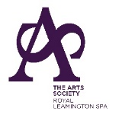 | THE ARTS SOCIETY ROYAL LEAMINGTON SPA  BIENNIAL DINNER 2024 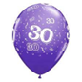

Thursday 27th June 2024

To Start
Heirloom Tomatoes, Basil, Mozzarella +/- Parma Ham (V)
OR
Classic Prawn Cocktail

Main Course
Roast Breast of Chicken, Buttered Leeks, Green Beans,
Minted New Potatoes and a Tarragon Sauce
OR
Braised Lamb with a Rosemary and Redcurrant Sauce,
Anna Potatoes and Spring Greens
OR
Roast Pepper filled with Roast Vegetables and Couscous with a Caramelized Red Onion and Chili Sauce (V)

Puddings
Red Wine Poached Pear, Vanilla Ice Cream and Lemon Balm
OR
Orange, Drambuie and Raspberry Pannacotta
OR
Fruit Platter

To Finish
Freshly brewed Coffee and Dinner Mints

